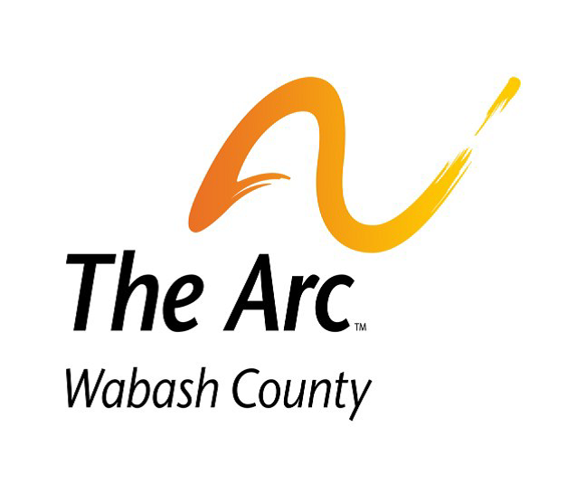
Annual Report to Membership July 2021

We Advocate, Care, Collaborate, Connect,
Empower, Include, and Innovate!

Fiscal Year 2021 (July 1, 2020 to June 30, 2021) was primarily focused on two tasks: reopening programs and services after the COVID-19 stay-at-home order and launching a new four-year Strategic Plan. Arc’s participants fully returned by August 2020 and all programs except for transportation services were up and running again by September 2020. Transportation services were fully restored by the end of October 2020. Even though participants, staff, and programs were affected by the COVID-19 pandemic of Spring 2020, The Arc Wabash County had a strong and vibrant year, providing advocacy, safety, and services to over 140 participants.

In February 2020, the Board of Directors adopted a new four-year Strategic Plan with seven strategic goals and seven core values. The Strategic Plan will guide The Arc through December 31, 2021. Arc hired Anne Hudson of Good Seeds Consulting of Indianapolis in February of 2019, and Anne facilitated the gathering of data and information from participants, parents, guardians, staff, education, social services, government agencies, business, and industry. The collected data was used to forge Arc’s new Strategic Plan, Goals, and Values. Arc’s seven strategic goals are Community Acceptance and Inclusion of People with Intellectual and Developmental Disabilities, Diversified Funding Streams to Support Programs and Services, an Engaged and Effective Staff, Expanded Programs and Services, Fully Incorporated Technology within the Entire Organization, and a new State-of-the-Art Facility. The Board and Staff are hard at work moving Arc on the journey of transformation into a bigger and better agency.

Below are some highlights of this past program year.

- A new Four Year Strategic Plan with Seven Strategic Goals adopted in February 2021
- PPP Covid Loan Approved and Submitted to Small Business Administration for Conversion to a Grant
- BDDS Sustainability Grants in the Amount of $148,776.
- AWS Foundation improving accessibility to employment for high school youth with a $2500 grant to provide paid work experiences for high school students and a college intern to work in our Pre-ETS (high school) summer program.
- Community Foundation of Wabash County providing $5,000 for staff training opportunities
- Passage of the Indiana State Budget which Included $40,000,000 over the Next Two Years to Raise the Wages of Direct Support Professionals and Job Coaches
- A 91% Success Rate in Our Organizational Goals and over 95% Customer Satisfaction Rating Across All Programs and Services
- Pre-Vocational Industrial Program Generated $427,000 in Revenue – A New All-Time Record
- Increasing Community Inclusion and Integrated Employment for People with IDD by Arc’s Pre-Vocation Industrial Program Beginning a New Embedded Work Team at Global Precision Parts
- Concerted Effort to Expand Arc’s Footprint and Presence in the County by Joining First Fridays, the Farmers Market, Rotary, Young Professionals, and Initiating Collaboration Conversations with Daniel’s Place, Grow Wabash County, Wabash Marketplace, Wabash City Police Department, Branding Two Arc Vehicles with the Arc Logo, and Posting Large Roadside Signs with Burkhart Advertising
- Transportation Program Sold Two Vehicles
- Successful Safety Inspection by InSafe
- Spectacular Community Support in Donations to Purchase a New Box Truck from Wabash Trucking in September 2020
- Concerted Efforts to Enhance and Expand Advocacy for People with Intellectual and Developmental Disabilities by Creating the New Advocacy, Human Rights, and Inclusion Sub-Committee, and Reconvening Council of Persons Served Meetings after COVID
- Improving Accessibility to the Building by Adding a New Ramp, New Platform, and New Stairs at the Miami Street Entrance in October 2020 (Gaunt & Sons Asphalt and Schlemmer Bros)
- Improving Accessibility to Technology for People with IDD by Purchasing Three New Large Screen TVs in October 2020
- Improving Safety in Arc’s Residential Program by Fully Integrating Electronic Visit Verification as Mandated by the Social Security Administration
- Improving Competitive Integrated Employment for Adults with IDD by Securing 2 New Jobs for Participants, assisting 6 Participants with Returning to their jobs after the COVID Epidemic, assisting 1 Participant with Entering College, and Assisting 1 Participants in Securing a Driver’s License
- Expanding Community Support for Persons with IDD by Hiring a New Art Instructor
- Improving Support for Persons with IDD by Hiring Two New Case Coordinators in Summer of 2020
- Provided 15,414 One Way Trips in Arc’s Transportation Services
- Enriched the Lives and Supported the Independence of People with IDD by Leading a Vacation Trip to the Wisconsin Dells in July 2020 and a Trip to Disney World in December 2020
- Provided Intense Advocacy to Help a Resident Secure His REAL ID from the Government!
- Welcomed a New Resident to Arc’s Sinclair Street Supported Living Program!
- Celebrated with a Participant who Earned Her GED in February 2021!
- Provided Services to 187 Persons Across Nine Different Programs (Community Support, Community Employment, Supported Employment, Pre-Vocational, Residential, Participant Assistance and Care, Respite, Pre-Employment Transition Services, and Transportation)

The Arc Wabash County recognizes the obstacles and risks ahead of us in the new program year, such as continuing to navigate COVID-19, much larger industry competitors, the continuing labor shortage, and an aging facility. However, with our new Strategic Plan, we are confidently looking forward to the next four years of change and transformation as seek to provide advocacy, programs, and services for Wabash County residents with intellectual and developmental disabilities.

The Board of Directors for Fiscal Year 2021 were Cathy Garrett-Smith, Gary Larson, Casey Sausaman, Kathy Baker, Ann Higgins, Jeff Kolkman, Shelly Myers, and Mike Barnett.

Respectfully Submitted,
Jeff Patton
President/CEO
The Arc Wabash County

